

2 Minute Form
Trip Name: Mahurangi Area
Check-in Name and Phone:
Date: Branch: Auckland
Leaders
Cell Phone Number
VHF Call Sign &/or Vessel Name
Vehicle make, model, registration, colour
General Plan
Note: If plan changes, you must notify your Check-in person.
Latest Time Off the Water |  |  |  |  | TMP used²⁰
Tide/ Forecast Lake Level | Low |  |  | High | Other
Communications Carried²¹
Communications | We will be communicating as a group on VHF Channel
Equipment Carried
Trip Report
(Use other side if more space required)

Activity | Club Trip | Centre | Auckland | Location Outer Harbour and Mahurangi Estuary |  |  |  |  |  | Difficulty¹ |  |  |  | Intermediate, or strong beginners if conditions are good
Activity Description | A single or multi-day trip exploring the Mahurangi Harbour, and/or to local islands, bays and inlets |  |  |  | Leader qualification req.² |  |  | Club Trip Leaders
Get in Location | Sullivan’s Bay / Te Muri |  |  |  | Chart/ Map no.⁴ |  |  | 532 |  | Distance |  |  |  | various
Get out Location | Sullivan’s Bay / Te Muri |  |  |  | Coastguard Channel |  |  | 82 & 16 |  | Nowcasting |  |  |  | 21
Emergency get out ⁵ | Moturoa Island, Saddle Island, Scotts Landing, Moturekareka Island, Mathesons Bay and others |  |  |  | Emergency / Coastguard Station |  |  | Auckland |  | Phone |  | *500 / 09 303 4303
Emergency get out ⁵ |  |  |  |  | Drinking Water⁶ |  | At Sullivan’s Te Muri & Motuora |  | Toilets⁷ |  |  |  | Long drops at Sullivan’s, Te Muri & Motuora
Emergency Response | Refer Emergency Response Booklet |  |  |  |  |  |  |  | Parking⁸ |  |  |  | At Sullivan’s Bay
Specific Equipment Required⁹ | Helmets advised if planning on rock gardening or surfing |  |  |  | Working Communications equipment in this area¹⁰ |  | Cell phone |  |  |  | Mountain Radio |  |  |  | PLB  VHF
Other resources  and notes¹¹ | Getting there – head north on the motorway, 5km past the tunnel there is a sign to Mahurangi West, turn right and travel for a few km. The road then bends to the left and there is a road which branches off to the right. Take the road to the right and follow it to the beach. This is Sullivan’s Bay aka Otarawao Bay on Google Earth.  As we may be visiting local Pest free Islands – ensure that kayaks and gear are checked for pests – rodents, Argentine ants, Rainbow skinks, seeds. Details… http://www.yakityyak.co.nz/Auckland+Yakity+Yak+Kayak+Club/Treasure+Islands+Pest+Free+Warrant.html |  |  |  | Weather Parameters¹² | Beginner: no significant surf or swell, wind under 15 knots.  Intermediate: surf or ocean swells less than 1.5 metres or wind under 25 knots.  Advanced: any condition that’s suitable for the trip’s aims.
Previous incidents¹³

Safety Management¹⁴
Hazard |  | Significant?  - E/I/M |  | Management Strategy¹⁵ |  |  |  | Hazard | Significant?  - E/I/M | Management Strategy¹⁵
Cold Water |  | Yes - M |  | Carry spare dry clothes and shelter |  |  |  | Deep Water | Yes - E | Correctly fit PFDs
Medical Conditions |  | Yes - M |  | - Leader has first aid qualification  - Ask customers about medical conditions |  |  |  | Bad Weather | Yes - M | Understand weather forecasts.  Have back up plans or pull out if necessary
Capsizing |  | Yes - M |  | - Correctly fit PFDs  - Skills at performing rescues. |  |  |  | Heat / Sun | Yes - M | - Protective Clothing (worn), Sunglasses, Hat  - Sun Screen  - Plenty of drinks
Panic |  | Yes - M |  | Ensure conditions match level  of skills |  |  |  | Obstacles | Yes - M | Awareness of reefs, navigational hazards, nets
Rock Gardening & Surf |  | Yes-M |  | There is the potential for ocean swell coming on to the islands – ensure that those participating have the skills required for the conditions on the day, particularly if rock gardening or surfing, in which case helmets are recommended. |  |  |  | Other Vessels | Yes - M | - Understand the “rules of the sea”  - “Be seen” – Have two of the following; flag, brightly coloured kayak, brightly coloured Pfd or hat. At night: an all- round white light & a powerful torch.
Written up by: | Shaun Maclaren |  | Approved By: |  | Russ Williams | Signed: | RW |  | Date: | 1 Oct 2014 | Review in: | 12 months from date of approval

Additional Information Sheet (Optional)
Introduction (A general introduction) |  | This is a great spot for a base to explore the Mahurangi Harbour and further. There is a wealth of destinations for day or multi-day trips in this area. There are campgrounds at Sullivan’s Bay, Te Muri, Big Bay, Vine House and Motuora (note there is a specific TMP for Motuora).
Other Information |  | Please make your own campsite bookings with Auckland Council, ph 09 301 0101, or online here http://regionalparks.aucklandcouncil.govt.nz/mahurangi/te-muri-beach-campground  You will also need to pay for overnight car parking at Sullivan’s Bay ($5 per vehicle per night). It is recommended that you phone Auckland Council 09 301 0101 and pay by credit card. You are also able to contact the ranger and pay cash on the day, but this is not their preferred method.
Local Attractions |  | Transport/ Local Operators
 | Contact details |  | Contact details
Accommodation/ Campsite Locations |  |  | Facilities
Name | Various local campsites, Sullivan’s, Te Muri. etc |  | Cabins | No | Fuel | No
Phone | 09 301 0101 |  | Showers | No | Power | No
E-mail | regionalparks@aucklandcouncil.govt.nz |  | Toilets | Long drops | Water Access | Yes
Website | http://regionalparks.aucklandcouncil.govt.nz/mahurangi/te-muri-beach-campground |  | Laundry | No | Pool | No
Physical Address |  |  | Water | Yes | Fires Allowed | No
Other |  |  | Supplies | No
Other information
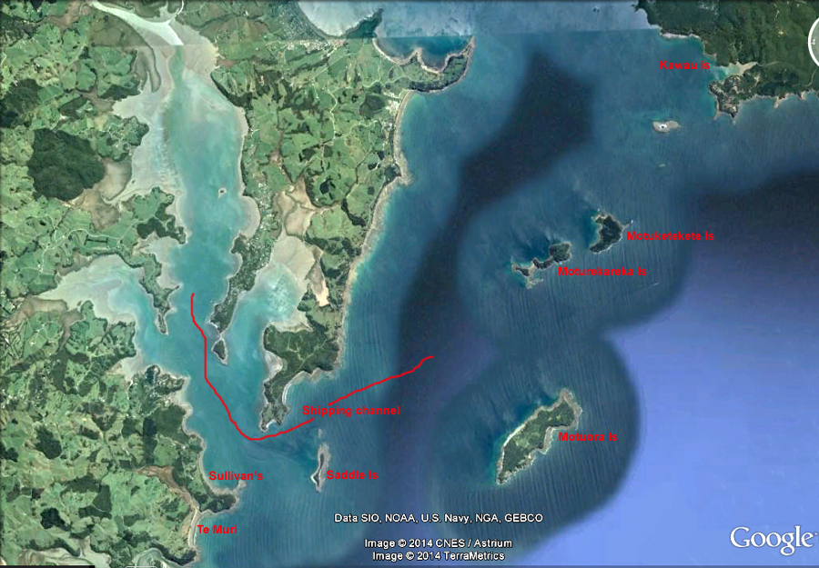

Activity Equipment Check list
Equipment List
- Helmet (rivers & surf) Group Gear
❑ Beanie / hat  Split paddles
❑ Thermals  Repair kit
❑ Paddle Jacket  Fire lighting
❑ PFD  Cooker/thermos
❑ Spray deck  Spare thermals
❑ Booties  Tow system
❑ Water & food  1st Aid Kit
❑ Kayak & paddle  Flares
Group - Oceans & Lakes  Compass
❑ Pumps & Paddle Floats  Charts / Maps
Group - River  GPS (optional)
❑ Throw ropes  Knife (cut rope)
❑ Pin kit & saw  Emergency Shelter

In case of emergency: Dial 111, Mayday :VHF Channel 16

Kayaking Check list

❑ Trip plan
❑ Latest weather forecast
❑ Conditions match skills?
❑ Hyperthermia (hot) &
Hypothermia (cold)
❑ On & off water safety
❑ Environmental concerns
❑ Emergency Procedures include emergency get out.
❑ Working communication devices
e.g. VHF radio, mobile phones, PLB
❑ Specific safety issues for this trip
❑ Participant list
❑ Any medical conditions
❑ All participants keen to proceed?

❑ Trip Plan/ 2-minute form lodged with Ops. Manager

Appropriate wind conditions to run trips:
Novice - no significant surf or swell, wind under 15knots
Intermediate- surf or ocean swells less than 1.5 metre or wind under 25 knots.
Advanced- any condition that is suitable to the trips aims

At conclusion of trip:
Contact check in person
Group Debrief.

Check in Person Ph:
__________________ Mobile
__________________ Work
__________________ Home

Activity Document Cover Sheet

Activity:
Date of Activity:

Activity reports. Is all relevant information present:
– Approved Trip Management Plan (TMP)/ 2 minute form
– Club Trip Participant Sheet
– Weather forecast
– Activity Check List
– Trip report (May be on the 2 minute form)
– Accident / incident reports
Leaders Signature:
Date:

